KU Libraries – Procedures
Public Services

Table of contents:

Opening and closing procedures for KU Libraries

Library Counters and other Statistics

Replacement of Lost or Damaged Library Items

Reimbursing Lost Book Payments (Expense Claim)

- Library Clearance

- ILL/Document Delivery Services

Opening and closing procedures for KU Libraries

The main entrance of the library should be opened by the security guard in the presence of a library staff member during scheduled opening hours, the Library should be open on scheduled opening hours.
General Checks
- Check the Book Drop at the entrance of the library. If you find any items in the Book Drop put them at the information desk for processing.
- Take all lost and found items from the previous day to the Reception after all the opening tasks have been performed.
- Make sure that the copier and printers are loaded with paper.
- Check the request list. (Automatic email notices are sent to staff to alert them if someone placed a hold on an item.) If there is a request, retrieve the book, check it in and place it on transit hold shelf. Do not inform the requestor at this point. Notification to the requestor should only be done once the item reaches the requested location.
Ensuring General Readiness of the Library
- Take a quick look around the library make sure that everything is ready for use, if you find anything broken or needs to be fixed request a help desk and make sure to notify your colleagues.
- Inspect and straighten around the international and local newspapers.
- Look for any notes from the evening staff as to any special conditions or events that occurred from the night before. If there are any urgent notices, alert one of the librarians or the security (depending on the situation) IMMEDIATELY.
- Look in all carrels for any items that may have been left from the night before. Place any found item on the lost and found drawer at the circulation desk. Any valuables like passports, phones, wallets need to be turned over to Reception for proper action.

Closing Procedures for library branches

This Closing Procedure is to be followed by all Library personnel whenever they may be required to close the library.

Pre-Closing Tasks

- 30 to 40 minutes (more if crowded) before closing, go to the General Collection, Periodicals, reference and study room areas with a cart, place any left items on the cart If you have time, re-shelve the items.
- Walk to the General Collection area and ensure that all books are in their appropriate place.
- Any personal property that’s found at this time should be taken to the Circulation Desk and placed in the ‘Lost and Found’ area.
- 15 to 20 minutes before closing time politely remind the students about our closing time and ask them to do all copying or research in the next 10 minutes so that we may close on time.
- Write in the communication book any information that may be useful for the opening staff the next day. It may be pending Work Order requests that need follow up the next day, Library needs like toners, paper etc., and other urgent information on other matters.
- Wait for security to close the Library door before leaving. Staff should not leave the Library while there are still students or security inside the Library premises.
- Look in all carrels and on tables for any items that may have been left from the day before. Place any found item in the lost and found tray at the circulation desk. Any valuables like passports, phones, wallets need to be turned over to S.O.S. department for proper action.

Library Counters and other Statistics

Keeping track of Library statistics such as head counts and gate counts is important in Library operations. These statistics give us a good idea of the high usage times of the day, plus it gives us additional data for the evenings that could be used to determine the need for more evening hours.
Entrance Statistics
The entrances to KU libraries are equipped with security alarm gates that have built in traffic counters. These gates are equipped with sensors that detect and keep track of the number of people entering and exiting the location in which they are installed.

Anyone on duty in the Circulation Desk area, whether Library staff or Library student assistants, are expected to login and open the smart gate manager module on their computers and copy the number to the excel sheet kept in a Library share folder.

Head Counts

Staff on duty in the Circulation Desk is expected to conduct regular head counts in their areas using the online web application SUMA. This application enables Library staff to count not just the total number of students in the Library at a given time but it also enables staff to count the number of students at different parts of the Library.

These counts are done in the middle of each hour and are important in giving not just a general idea of peak and low hours in the use of the Library, but with the use of SUMA, the Library is going to have a more detailed picture of the use of Library space.

Replacement of Lost or Damaged Library Items

Any item in a user’s account is their responsibility. In cases when an item is lost or severely damaged, the user shall have to pay for the full cost of replacing the item.

- When an item is lost or damaged, the following procedure shall be followed:

- When staff is informed of a lost item, a block is placed on the user’s account until settlement.

- The item cost is determined by taking the current price at addall.com or other reliable source and converted to dirhams (exchange rate 1USD=3.675 AED).

- An additional 50 AED replacement processing fee is added to this price.

- The circulation Desk and a library assistant will contact the user who has lost the item to inform them of the total cost of replacement.

Below are the guidelines for the payment of lost and damaged items:
- Go to circulation and open the patron record.

- Click on ‘Fines’.

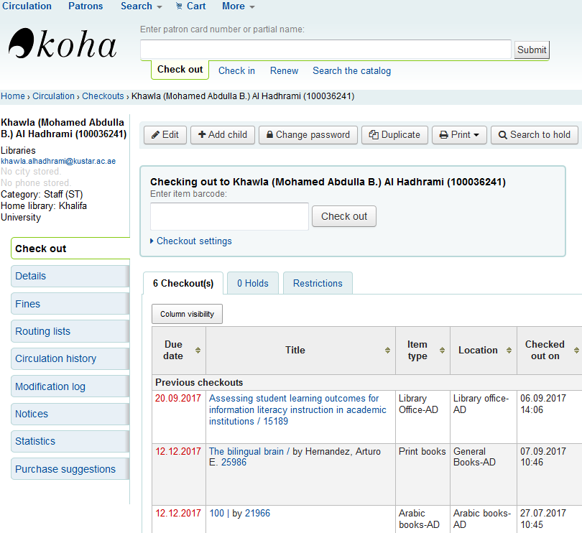

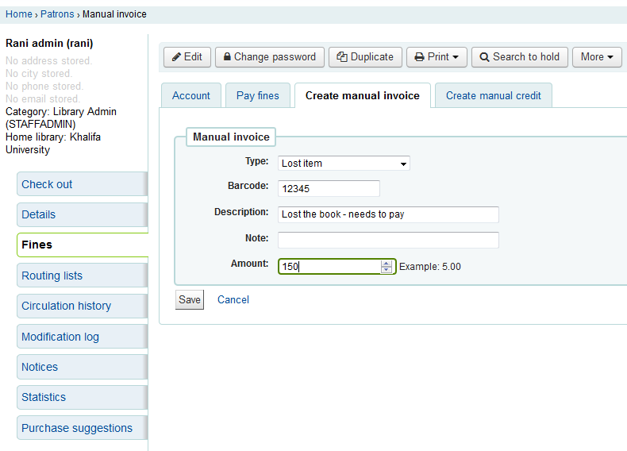
- Click on ‘Create Manual Invoice’.

  - The default under type is ‘Lost item’.

  - Fill in all the rest of the required details then click on ‘Save’.
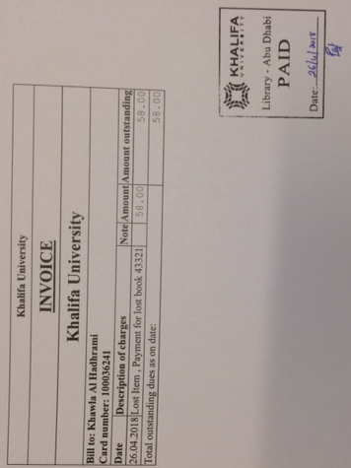
  - Note: The price of lost books could be checked from the item record. If there is no price in the item record, check OASIS or Gobi for the price of a new book and convert to UAE Dirhams.

- Under Account, click on ‘print’ button for the lost item. An invoice will be printed.

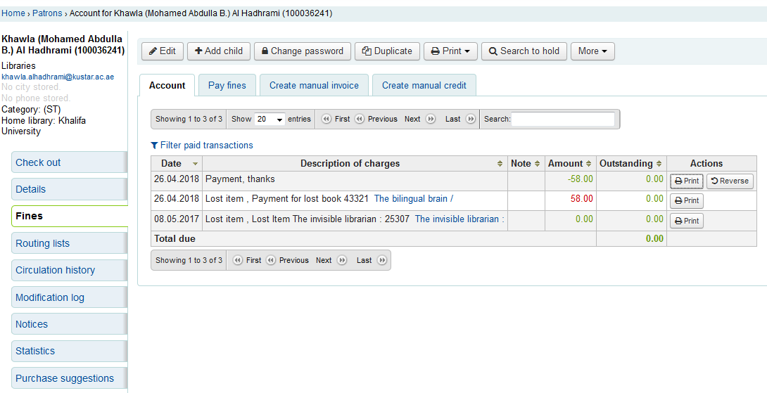
To print the receipt, click on the ‘print’ button for the description ‘Payment, thanks’.

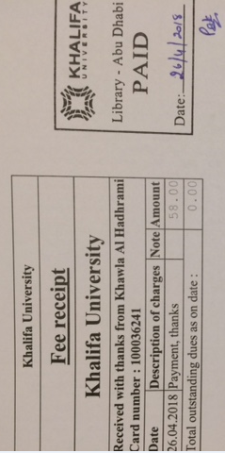

- Collect the money and put in the money box.
- Print 2 copies of the receipt and invoice. Stamp using the PAID stamp on all.
- Give a copy of each to the patron and file the other copy in the ‘receipts’ file at circulation.
- At the end of the month, send all invoices & receipts, along with the money to Mohammed Nasser at SAN campus library. Money should not be sent by internal mail.
- Staff will fill in the ‘lost & paid’ form with all the details and get it approved by the library management.
- ‘Lost & Paid’ form, copies of all invoices and receipts, and the money are sent periodically to finance.
- Finance acknowledges receipt of money and paperwork, then sends back a ‘receipt voucher’ to the library for record keeping.
- Receipt voucher is attached to the concerned paperwork and filed

Reimbursing Lost Book Payments (Expense Claim)
In cases the user loses and pays for an item, but later finds the book, the user has no option to refund the amount paid as per Finance department directions.

Library Clearance
Library clearance is usually processed online and can be done by any library or ILC staff. Library clearance is for students withdrawing or graduating, or employees who are leaving KU. Responsible staff are notified via email when a new clearance is ready for processing.
To process a clearance:
- When the email is received, a staff member will go to the URL in the email to see the status. In the rare occurrence when the system is down, the Student, Faculty or Staff member will present his ID card and paper form at the circulation desk.

- Check the KOHA record for the Library user. If the user has items still checked out, do not approve the clearance. In the electronic form, mark it on hold. Notify the users that they need to resolve the issue before clearance will be approved. Items must be returned or paid for (if lost or damaged) before any clearance granted.

- If all items have been returned, go to the Library user’s record and change the status of their account to BARRED and leave a note such as “withdrawn from KU”, “left KU” or “graduated from KU”. Also add in the note when the clearance was signed.

- Approve the online clearance form or sign the paper clearance form and include the date when the clearance was signed.

- If the user has any concern, refer the user to the Library Management.

VI. ILL/Document Delivery ServicesReceiving Requests
- Prior to making ILL/DDS request, users should verify that the library does not have access to the desired item in libraries holdings. The Library team should also verify and double check availability of the items in current KU libraries holdings before proceeding with any requests.
- Requests are only accepted via the online request form or by sending an email to the assigned ILL account (ill@ku.ac.ae).
- When requesting materials, the user will make sure that all required fields are duly completed, avoiding initials and abbreviations. Missing or incorrect information will slow requests fulfilment, or make them impossible to fulfill.
- Requester should indicate preferred format in the request. Otherwise, the library will acquire the item in the most convenient format (i.e ebook; book chapters; Journal article; proceedings, etc.)

Fulfilling requests and notification

- All communication with the requestors are made via email when receiving request and fulfilling it.
- Requested articles that are acquired by the library in electronic format will be delivered to the requestor electronically (usually via email) as well. The requestor would be personally responsible for printing the item, if that is needed.
- Physical items (British Library books and hard copy ILL documents) must be picked up in person at the circulation desk of the library that the requestor indicated when they made the request.
- The lending period for physical items (BL books) is determined by the lending library (BL), and the KU libraries have no control over this time period.
- The lending library might have policies which forbid renewals for some items. If an item falls in such a category, then no renewals can be made.
- If the requestor wishes to have the ILL item renewed (BL book), the requestor should notify the ILL team a week before the due date indicated on the book jacket.
- Borrowed BL books may be returned to any library location, but eventually should be sent to the ILL team at Masdar Campus Library in order to return/ship the BL book to UK.
- Interlibrary loan items should not be placed in the library book drop.
- Users who fail to return items by the due date will have their ILL and document delivery privileges suspended until items are returned.
- Long-overdue, damaged or lost items will be billed to the user for replacement.
- The library will attempt to get any item for users as soon as possible, however, turnaround time depends on availability of the document(s).
- Items that violate the cultural or legal standards of the UAE should not be requested via ILL or document delivery.

